Modeling Zero Energy Mixed Use Multifamily Buildings with OpenStudio®

OpenStudio® is a whole building energy modeling software platform used to model complex interactions between the building envelope, plug loads, daylighting, lighting, and heating and cooling equipment. It has an intuitive graphical user interface that helps the user navigate through different inputs for the energy model. A unique feature of OpenStudio® is that it provides the capability to quickly implement different energy efficiency and energy conservation strategies using a set of programmatic instructions called ‘measures. The purpose of using OpenStudio® for the Solar Decathlon Design Challenge is to evaluate the impact of these energy efficiency and energy conservation strategies on the energy use intensity (EUI) of the building and ensure that it is along the path to zero energy. The OpenStudio® software is available to download for free. ­

Table of Contents

Installing the OpenStudio® Application 2

Loading Solar Decathlon Design Challenge OpenStudio® Model (OSM) 3

Overview of Measures in the Workflow 6

Next Steps 7

Helpful Resources 7

# Installing the OpenStudio® Application

1. Go to <https://github.com/openstudiocoalition/OpenStudioApplication/releases/tag/v1.0.1>. At the bottom of the page under “Assets” for “OpenStudio Application Version 1.0.1” select the Windows, Mac, or Linux installer. ***Note that while there is a newer 1.1.0 installer, for this workflow you need to use the older 1.0.1 version of the OpenStudio Application.***
   1. Windows installer ends with “Windows.exe”
   2. Mac installer ends with “Darwin.zip”
2. Run the installer, and make sure all OpenStudio components are selected as shown below.

1. The OpenStudio Application icon should now show up on the start menu on Windows or in your applications folder on Mac.

# Loading Solar Decathlon Design Challenge OpenStudio® Model (OSM)

Launch the OpenStudio Application and open the “ze_multifamily.osm” model using the file menu. this can be found on the Solar Decathlon web portal. In addition to the OSM file will be a directory by the same name that contains measures and other files necessary to building up the model and run the simulation. Most of the model is generated by measures, but the model is pre-populated with some items which are described below.

What makes this workflow unique from others is that it has a mix of commercial space types on the first floor and residential space types above. While commercial space types use area normalized internal loads, the residential portion models individual applications and looks at the number of bedrooms and occupants to determine loads and schedules.

1. Ignore the site tab for now, the Change Building Location measure will assign a weather file, design days, climate zone, and water main temperatures. Constructions will also be assigned later based on the climate zone.
2. The model does not have any spaces or thermal zones but it does have a FloorSpaceJS floorplan shown below. The first floor is commercial, and floors 2-4 are residential
   1. The geometry editor can be used to view or edit the floor plan. Note if changes are made instead of merging back to the OSM, leave it un-merged. The ﻿ResidentialGeometryCreateFromFloorspaceJS” measure will merge it in.   
        
      Graphical user interface

      Description automatically generated
   2. More on replacing or altering the floorplans is discussed in “Overview of Measures in the Workflow” section.
3. Space type names used in the floorplan should also be in the OSM. One except is the “living” space type assigned to the apartments in the floorplan It doesn’t have to be in the OSM model.  
     
   A screenshot of a computer

   Description automatically generated
4. The next relevant tab is the Measures tab. Each of the measures is described in the “Overview of Measures in the Workflow” section.
   1. Most of these measures can be ignored for now, but one you want to address is the Change Building Location measure. You want to change the EPW file to one that matches your location. Make sure to include not only that EPW file, but also the DDY and STAT file in the “files” directory for this model.
   2. Generally, you can leave the argument for climate zone to “Lookup from Stat File” but sometimes you might have to manually set that.  
      
5. Run the simulation using the Run tab, which is the next one after the measure that has the arrow pointing to the right. Once on that tab click the green arrow to start the simulation.
6. When the simulation is done, you can move to the next tap, the Results Tab, to view simulation results.

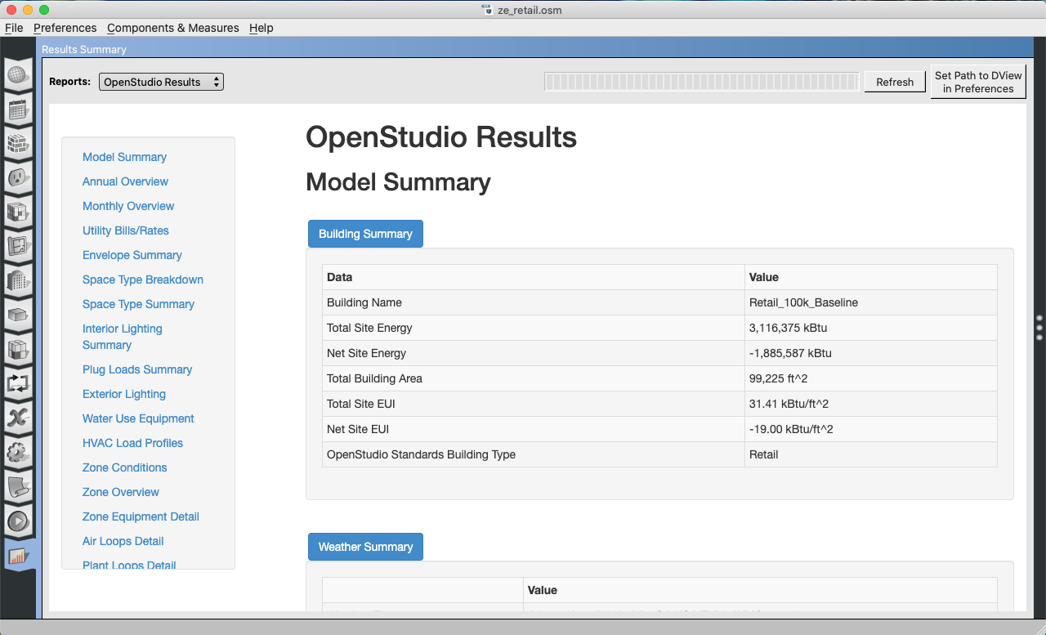

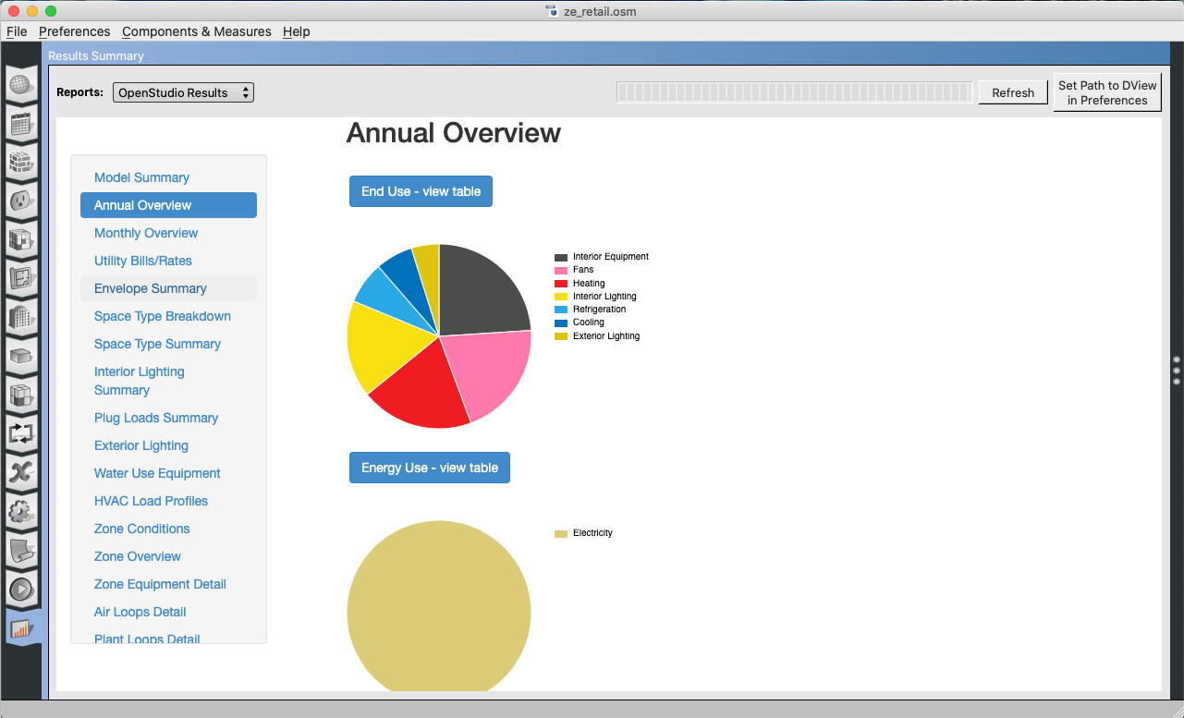

# Overview of Measures in the Workflow

1. OpenStudio Measures (these pass an OpenStudio model, alter it, and pass a modified OpenStudio model out)
   1. Change Building Location
      1. Changes weather file, design days, water main temperatures, and climate zone. The proper climate zone is important for how many of the other measures work. Typically, this will be set by “Lookup From Stat File”.
   2. Set Window to Wall Ratio by Facade
      1. Apply windows to South, East or West facade. The north has service access.
      2. Rotation can be changed after windows are applied to have the service façade face a different direction.
   3. Add Overhang by Projection Factor
      1. This is also available for South, East, and West facades.
   4. Rotate Building
      1. This was place after the orientation specific window to wall ratio measures. If you add and a window to wall ratio to the south facade and then rotate 90 degrees, those windows no be on the west facade.
   5. Add Daylight Sensors
      1. Will place daylight sensors in the building and connect it to electric light controls.
   6. Zero Energy Retail Typical
      1. This adds constructions, internal loads, and mechanical system to the model.
      2. There are many options for this measure that are discussed in next steps.

* 1. Add Typical Refrigeration
     1. Has an input for linear feet of refrigeration.
  2. Add Rooftop PV
     1. Creates shading surfaces with photovoltaics above the roof. There are arguments for cell and inverter efficiency for fraction of roof covered.
     2. Note, that the surface will always be the size of the entire roof even if fraction is less than 1.0, but the surface is model as translucent surface matching the PV fraction.
  3. View Model
     1. Provides an interactive 3d view similar to the geometry tab of the OpenStudio Application.

1. Reporting Measures (these run on EnergyPlus Sql database after simulation is done to produce an html file)
   1. OpenStudio Results
      1. Annual and monthly simulation results

# Next Steps

Below are a few examples of ways to customize this workflow.

1. Change fenestration and overhangs
2. Change PV coverage and characteristics
3. Zero Energy Retail Typical Customization
   1. Change target level of performance “Template” for constructions and HVAC system efficiency.
   2. Change target level of performance for internal loads
   3. Select from a few dozen HVAC system types
   4. Alter exterior lighting levels
   5. Change start of and duration of hours of operation for weekdays and weekends.
4. Create your own floor plans.
   1. Use the Floorspace JS feature in the editor sub-tab of the Geometry Tab. This functional is documented below. Opening the seed model for the PAT project will provide access to a starting floor plan.  
      [*https://nrel.github.io/floorspace.js/docs/*](https://nrel.github.io/floorspace.js/docs/)
   2. Import gbXML file, or model with the OpenStudio SketchUp Plugin.
   3. If you use one of the methods above to replace or alter geometry you need to assure that thermal zones have been added for spaces and surface boundary conditions have been set through surface matching, which is available as a measure on the Building Component Library.

# Helpful Resources

* OpenStudio® user documentation   
  <http://nrel.github.io/OpenStudio-user-documentation/>
* Installation and introductory tutorial   
  <http://nrel.github.io/OpenStudio-user-documentation/getting_started/getting_started/>
* Parametric Analysis Tool Documentation   
  <http://nrel.github.io/OpenStudio-user-documentation/reference/parametric_analysis_tool_2/>
* Technical Feasibility Study for Zero Energy K-12 Schools <https://www.nrel.gov/docs/fy17osti/67233.pdf>
* Technical Support Document for Zero Energy K-12 Schools will be published at a later date.
* [ASHRAE Zero Energy Design Guides](https://www.ashrae.org/technical-resources/aedgs/zero-energy-aedg-free-download)
* UnmetHours (please use tag “solar-decathlon” when posting questions. Only post energy modeling questions, not Solar Decathlon Design Challenge questions.)   
  <https://unmethours.com/questions/>
* [SDdesign@nrel.gov](mailto:sddesign@nrel.gov)